Mathematical Equation

🌟 Definition
# Source: AI Source: Provided by: [Data Path: Persons Table -> ID Column: 1, Name_En Column: Motasem Essam] -> From: [ChatGPT] on [5/29/2026]
A mathematical equation is a statement that shows that two mathematical expressions are equal, using the equality sign (=).
An equation expresses a balance or relationship between two sides.

🎯 Purpose of an Equation
# Source: AI Source: Provided by: [Data Path: Persons Table -> ID Column: 1, Name_En Column: Motasem Essam] -> From: [ChatGPT] on [5/29/2026]
- To show equality between expressions
- To solve for unknown values
- To model real-world problems
- To express mathematical relationships
- To form the basis of many mathematical problems

📚 Key Characteristics
# Source: AI Source: Provided by: [Data Path: Persons Table -> ID Column: 1, Name_En Column: Motasem Essam] -> From: [ChatGPT] on [5/29/2026]
A mathematical equation:
- Contains an equals sign (=)
- Has a left-hand side (LHS) and right-hand side (RHS)
- May include variables (unknowns)
- Can be true or false depending on values
- Can be solved or simplified

🧩 Structure of an Equation
# Source: AI Source: Provided by: [Data Path: Persons Table -> ID Column: 1, Name_En Column: Motasem Essam] -> From: [ChatGPT] on [5/29/2026]
$$\text{Left Side}=\text{Right Sid}\text{e}$$
Example structure:
- LHS: expression
- RHS: expression
- Equality sign: =

✏️ Examples of Mathematical Equations

1. Simple Equation
# Source: AI Source: Provided by: [Data Path: Persons Table -> ID Column: 1, Name_En Column: Motasem Essam] -> From: [ChatGPT] on [5/29/2026]
$$x+2=5$$

2. Quadratic Equation
# Source: AI Source: Provided by: [Data Path: Persons Table -> ID Column: 1, Name_En Column: Motasem Essam] -> From: [ChatGPT] on [5/29/2026]
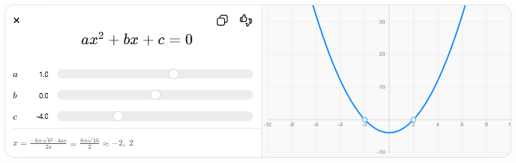
$$ax^{2}+bx+c=0$$
$$a$$
$$b$$
$$c$$
$$x=\frac{-b±\sqrt{b^{2}-4ac}}{2a}=\frac{0±\sqrt{16}}{2}≈-2, 2$$

3. Linear Equation
# Source: AI Source: Provided by: [Data Path: Persons Table -> ID Column: 1, Name_En Column: Motasem Essam] -> From: [ChatGPT] on [5/29/2026]
$$2x+3=7$$

4. Physics Equation
# Source: AI Source: Provided by: [Data Path: Persons Table -> ID Column: 1, Name_En Column: Motasem Essam] -> From: [ChatGPT] on [5/29/2026]
$$F=ma$$

🔗 Relationship to Other Concepts
# Source: AI Source: Provided by: [Data Path: Persons Table -> ID Column: 1, Name_En Column: Motasem Essam] -> From: [ChatGPT] on [5/29/2026]
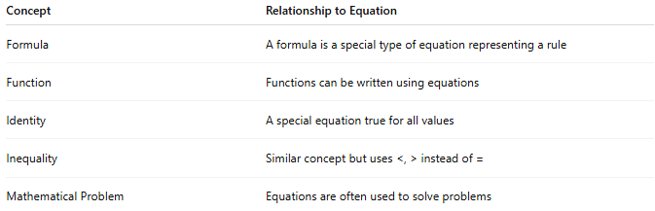
Concept | Relationship to Equation
Formula | A formula is a special type of equation representing a rule
Function | Functions can be written using equations
Identity | A special equation true for all values
Inequality | Similar concept but uses <, > instead of =
Mathematical Problem | Equations are often used to solve problems

📖 Equation vs Formula vs Identity
# Source: AI Source: Provided by: [Data Path: Persons Table -> ID Column: 1, Name_En Column: Motasem Essam] -> From: [ChatGPT] on [5/29/2026]
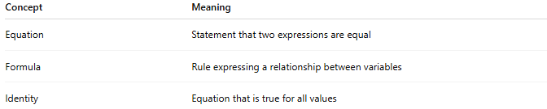
Concept | Meaning
Equation | Statement that two expressions are equal
Formula | Rule expressing a relationship between variables
Identity | Equation that is true for all values

🧠 Simple Analogy
# Source: AI Source: Provided by: [Data Path: Persons Table -> ID Column: 1, Name_En Column: Motasem Essam] -> From: [ChatGPT] on [5/29/2026]
A mathematical equation is like a balanced scale:
- Left side = Right side
- Both sides must be equal
- If one side changes, the other must adjust

🧭 Summary
# Source: AI Source: Provided by: [Data Path: Persons Table -> ID Column: 1, Name_En Column: Motasem Essam] -> From: [ChatGPT] on [5/29/2026]
A mathematical equation is a statement that shows two expressions are equal. It often contains unknown values (variables) and is used to solve problems, represent relationships, and model real-world situations.

